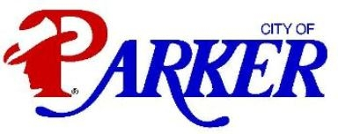
Parker Police Department
Chief Bill Rushing

WEEKLY POLICE BLOTTER: WEEK OF 07/28 -08/01/2014
LOOSE DONKEY | 1800 BLK DUBLIN RD
SUSPICIOUS VEHICLE | 3700 MCCREARY RD
SPECIAL PATROL | DUBLIN RD
AGENCY ASSIST (APD) | 5700 CHEYENNE
PUBLIC ASSIST PD WALK-IN | RUNAWAY REPORT
DOMESTIC DISTURBANCE | 5000 BLK DUBLIN CREEK
EXTENDED PATROL | PARKER LAKES 1 & 2
EXTENDED PATROL | RESERVE CT
MOTORIST ASSIST | ALLEN HEIGHTS@CHAPARRAL
ANIMAL AT LARGE | OLD CITY PARK
AGENCY ASSIST (CCSO) | 800 RUTHLEDGE LUCAS
AGENCY ASSIST (CCSO) | E. LUCAS @SOUTHVIEW
AGENCY ASSIST (APD) | SPRINGHILL ESTATES
PUBLIC ASSIST | PARKER ROAD
SUSPICIOUS PERSON | SPRINGHILL ESTATES
NOISE COMPLAINT | SPRINGHILL ESTATES
Parker Police Department
Chief Bill Rushing

WEEKLY POLICE BLOTTER: WEEK OF 07/14 -07/20/2014

